Student Name: _________________________________
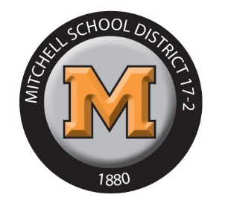

Mitchell High School 2022-2023
Senior Registration Form

 |  |  | Course Registration
 |  | Course # | Course Name/Semester A |  | Course # | Course Name/Semester B
 | 1. | 4400/4402 | Government or POLS (for Dual Credit) | 1. |  | English Elective
 | 2. |  |  | 2.
 | 3. |  |  | 3.
 | 4. |  |  | 4.
 | 5. |  |  | 5.
 | 6. |  |  | 6.
 | 7. |  |  | 7.
 |  |  | Alternative Course Choices
 |  | Course # | Course Name
1.
2.
3.
4.
5.
6

Parent Signature____________________________ Date______________

Anticipated Plans - College Technical College Military Workforce

Career Interests - ____________________________________________________

Courses are subject to availability and will be assigned accordingly. This is a registration form, NOT your schedule. Placement in off campus and dual credit classes MUST be completed through the guidance office when appropriate and available.

