Registration Directions for 22-23 School Year

- Log into your Campus Portal
- In left column scroll down to More – CLICK
- In box that appears in main screen, scroll to Course Registration – CLICK
- On 22-23 Mitchell High School – CLICK
- Add Course - CLICK
- Type in the COURSE NUMBER (not the course name) – CLICK
- When course appears – CLICK on it
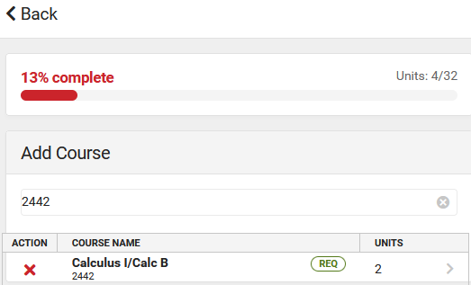
- Add Request appears in lower left corner – CLICK . . . . . . . . . Do Not click on Add Alternate

- Once a course is added, click the Back button in the upper left-hand corner
- Continue adding courses until the Units at the top right shows 28/32- Units 28/32
- After you have your 28 units selected, it is time to add your alternative class selections
  - Type in Course Number . . . . . Add Alternative – CLICK
- If you make a mistake, Delete Request – CLICK
- When you are done, you may just close the program
Thanks so much for getting this completed!!
Mrs. Fowkes and Mrs. Max

PLEASE turn over for dual credit information and other course numbers
DUAL CREDIT NUMBERS
My apologies. . . . . . . a mistake was made with the instructions for the registration of dual credit coursework
- You may only use a course number once, SO when registering for more than one dual credit class in a semester, use these numbers:
Fall – first semester DWU Bridge Program
- 9991 for your first dual credit request Use the number: 9996Bridge
- 9992 for your second dual credit request
- 9993 for you third dual credit request MTC Full Time
Spring – second semester Use the number: 9996MTC
- 9995 for your first dual credit request
- 9996 for your second dual credit request
- 9997 for your third dual credit request
Studyhall
- First Semester 481
- Second Semester 482

